Year 6 Overview: Autumn 2 term 2020
English | Values | Physical Education
Holes by Louis Sachar  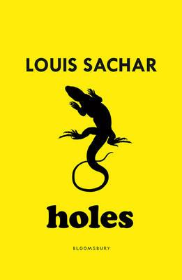  ’Stanley Yelnats' family has a history of bad luck, so when a miscarriage of justice sends him to Camp Green Lake Juvenile Detention Centre (which isn't green and doesn't have a lake) he is not surprised. Every day he and the other inmates are told to dig a hole, five foot wide by five foot deep, reporting anything they find. The evil warden claims that it is character building, but this is a lie and Stanley must dig up the truth.’  Holes was put on hold last term in favour of Mathew Syed’s ‘You are Awesome’ - a wonderfully inspiring read, perfectly suited for a cohort returning to school after months away. However, Holes is such a gripping read so we will be exploring it this half-term. We will continue to practise writing for a range of purposes, much of this will be written through the lens of Stanley Yelnats, the protagonist. | The Aspirations condition for this term is:  Heroes  Heroes are people who we respect and whose ideas we value. | With Mr White and our class teachers, we will continue to develop our balance and core strength skills within gymnastics. Children will learn how to successfully create different shapes whilst supporting one another. The fundamental skills they will be learning are:  *FLOOR SHAPES, FLOOR MOVEMENT, BENCH BALANCE, VAULT, CLIMBING AND TRAVERSING APPARATUS*  In GAMES, we will continue to develop our fundamental movement skills through INVASION GAMES:  *DODGING, KICKING, FOOT DRIBBLING, HAND DRIBBLING, CHEST PUSH, CATCHING, ATTACK & DEFENCE*
 | Maths | Geography
 | 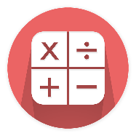  In maths this term, in addition to regularly revising our arithmetic, we will continue to focus on pupils’ specific areas for development.  Within these areas, children will be problem-solving and reasoning to deepen their mathematical understanding and apply their knowledge in real-life situations. | 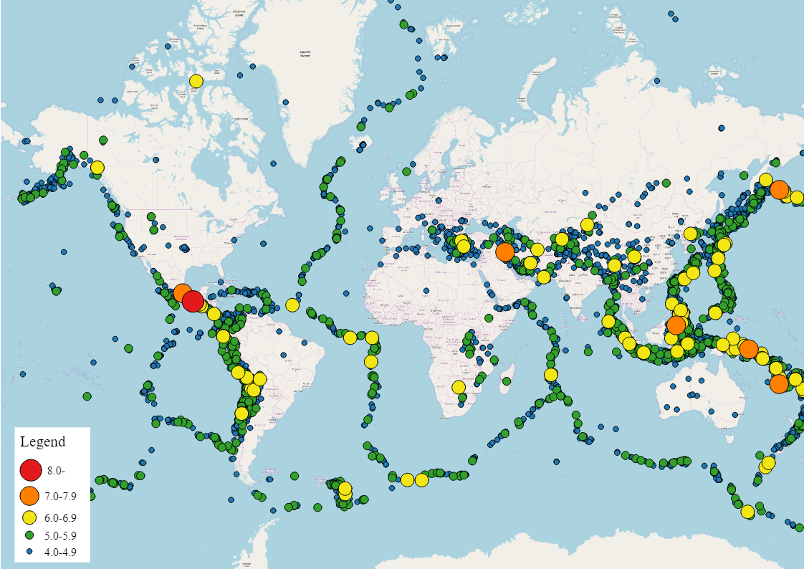  In geography, we will be learning about earthquakes. Children will learn about how, why and where earthquakes occur by exploring the physical make-up of our planet.
Creative | RE | Science
ART/DT:  In art, pupils will create their own personal artwork in the style of renowned street artist, Banksy.  D&T:  To enhance their knowledge of electrical circuits, pupils will create a simple alarm system.  MUSIC:  In music, pupils will continue to work towards creating a radio jingle using a digital music creation tool. | 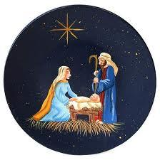  Towards the end of the half term, children will be studying the Christmas story. Although they will be familiar with the story, we will study it at a deeper level. In particular, they will study the role of Mary and why she was chosen. | In science, we will be studying electricity. Children will learn how to design, draw, create and debug simple circuits. We will conduct some investigations to answer questions such as: Does a wire’s length affect the brightness of the bulb/loudness of the buzzer? We will also learn about the early pioneers of electricity such as: Edison, Volta and Faraday.
Dates for your diary | Learning Skill | Computing
11/11/20 Remembrance Day  13/11/20 Mufti Day - Children in Need (donate online)  20/11/20 INSET Day - school closed  10/12/20 Flu immunisations  18/12/20 Last day of term - 1pm school pick up | This half-term’s learning skill is:  RESPECT  There will be an increased focus on being respectful this half-term. Children will learn that when they treat others respectfully, they can expect to be treated respectfully in return. | 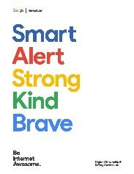  In addition to using computers for research and creating content across the curriculum, children will learn about Online Safety in their computing lessons. We will learn about: how to protect our personal data and, linking to our learning on anti-bullying and British values, how we can remain respectful online.

