YEAR 3: SPRING 1 – INVENTIONS
SCIENCE: Forces and Magnets
UNDERSTAND, DESCRIBE AND EXPLAIN: Forces
To understand and describe different types of forces and whether they are creating a push or pull reaction  To understand and describe the force of friction  To compare how things move on different surfaces  Learning links:  Year 5: Science  Forces  Year 3: DT  Building and testing magnetic cranes with a pulley system | Force |  | Push |  | Pull |  | Twist | Stop | Start
 | Balanced |  | Unbalanced |  | Size of force |  | Forces ‘acting’ on an object | Motion | Direction
 | Energy |  | Speed up |  | Slow down |  | Change direction | Friction | Rough | Smooth
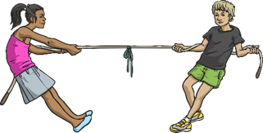
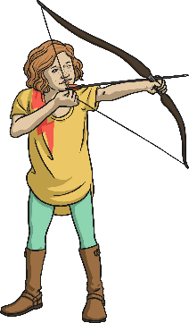
What is a force?
A force is a push, pull or twist acting on an object because of the object's interaction with another object. Forces can make objects stop or start moving.
Forces make things move. Whenever an object starts to move or moves faster, it is a force making this happen. Forces can also make things stop moving or slow down.
Can you think of times when you use a push, pull or twist force?

Balanced forces:
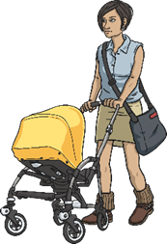
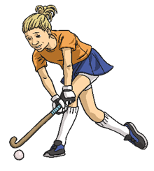
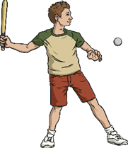
If two forces are balanced, it means the forces are the same size but are acting in opposite directions. If two balanced forces are acting on an object, that object will not change its motion. If it is still, the object will stay still or if it is moving, it will continue moving in the same direction and at the same speed.

Unbalanced forces:
When two forces acting on an object are not equal in size, we say that they are unbalanced forces. Unbalanced forces do change the way something is moving. They can make objects start to move, speed up, slow down or change direction.

How much force?
The amount of force needed to push or pull an object depends on the amount of friction or resistance acting on the object.
If an object is very heavy (weight), the size of force acting on the object to push or pull will need to be greater.
To push an object across a rough, bumpy surface (like a gravel path) would be very difficult. However, if that same object was on a slippery, smooth surface (like an ice rink), less force would be needed to push it across the surface because there would be less friction.

Friction:
Friction is a force that holds back the movement of an object. Friction acts in the opposite direction to the movement of the object.
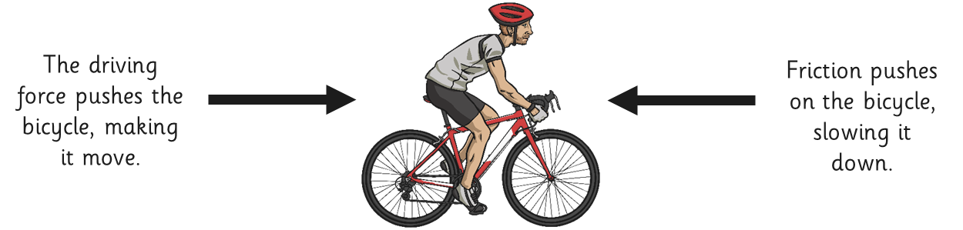
The amount of friction created by an object moving over a surface depends on the roughness of the surface and the object, and the force between them. For example, if you were riding a bike and stopped pedalling, you would eventually slow down and stop. This is because the friction of the tyres on the surface slows down the motion of the bicycle until it eventually runs out of energy from the force that gave it the forward motion (pedalling). If you were cycling on a particularly bumpy or rough surface, the friction would be greater and the bike would come to a stop sooner than if on a smooth tarmac road. Would it be easier to cycle on a smooth road or a sandy path?
EXPLORE AND INVESTIGATE:
HYPOTHESISE  ENQUIRE  TEST  RECORD  REPORT  CONCLUDE | 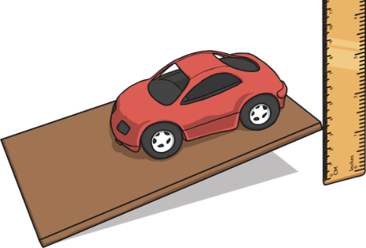  Investigating friction:  - Locate some boards covered in different surfaces with varying textures (rough and smooth), a ruler and a toy car.  - Place the car at the end of one of the boards.  - Place the ruler at the side of the board, so you can measure the height of the board as you lift the end.  - Lift the end of the board that the car is on 1 cm at a time.  - Watch the car carefully, and notice at what height it starts to move. Record this measure.  - Try this with each of the boards covered with different surfaces.  - Record the results in a table and evaluate the findings.  - What did you discover? Which surface created the most friction? Which surface created the least friction? Was your prediction accurate?
KEY ASSESSMENT AND APPLICATION OPPORTUNITIES:
EXS:  What is a force?  How can we make objects move?  If I push/roll a ball or toy car on any surface, why does it eventually stop? Is it the same for every surface? |  |  |  |  |  | GDS:  How can friction be a useful force in everyday life?  Design a pair of shoes that would help an explorer who had to travel on the following surfaces:  - Ice  - Boggy mud  - Rough, rocky terrain
UNDERSTAND, DESCRIBE AND EXPLAIN: Magnets
To understand that magnetic forces can act at a distance because of the magnetic field  To understand magnetic force and how some objects are magnetic and others are not  To describe magnets as having two poles and understand whether magnets will attract or repel  Learning links:  Year 5: Science  Forces  Year 3: DT  Building and testing magnetic cranes | Magnet |  | Force |  | Magnetic force |  | Magnetic field | Materials | Magnetic materials
 | Attract |  | Repel |  | Magnetic materials |  | Non-magnetic materials | Invisible | Metal
 | Iron | Cobalt | Steel | Nickel | Attracted |  | Magnetic Poles | North | South
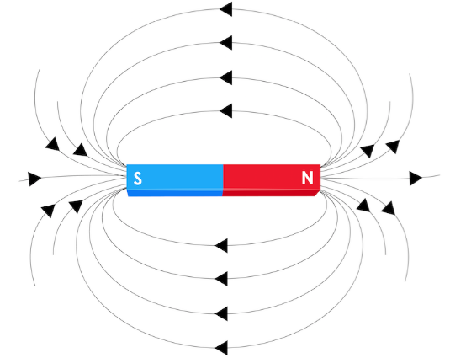
What is a magnet and a magnetic field?
A magnet is a special type of object. It produces an area of magnetic force around itself, called a magnetic field. The magnetic force in a magnet flows from the North pole to the South pole. This creates an invisible magnetic field around a magnet.
If certain materials enter this magnetic field, they will be attracted to the magnet. This will cause the materials to stick to the magnet.
For example, as you move a magnet towards a steel nail, the nail will eventually enter the magnetic field around the magnet, it will 'jump' towards the magnet and stick. The magnetic force within the magnetic field pulled the nail towards it. Therefore, the steel nail is magnetic!
The stronger the magnet is, the larger its magnetic field will be. Therefore, it will be able to attract magnetic objects from further away and hold heavier weights of magnetic objects.
Invisible magnetic field
There are lots of types of magnets and they have varying magnetic strength, shape and size:
Bar magnet | Cylindrical magnet | Horseshoe magnet | Button magnet | Ring magnet | Square magnet | Arc magnet

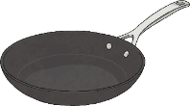
Which materials are magnetic?
Magnetic materials are always made of metal, but not all metals are magnetic.
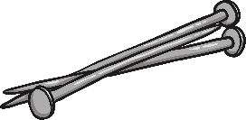
Iron is magnetic, so any metal with iron in it will be attracted to a magnet. Steel contains iron, so anything made of steel will be attracted to a magnet. Most other metals, for example aluminium, copper and gold, are NOT magnetic.
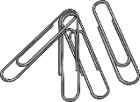
Metals, which contain iron and are therefore magnetic, are: Iron, cobalt, steel and nickel. A good way to remember this is: ‘I Can See Nick’. You can test if a material is magnetic by holding a magnet close to it to see if it attracts or not.

What are magnetic poles?
All magnets, regardless of their shape and size, have two different parts called the poles. There is a north pole and a south pole.
The magnetic force in a magnet flows from the North pole to the South pole. This creates a magnetic field around the magnet. Magnetic force is strongest at the ends of the magnet.
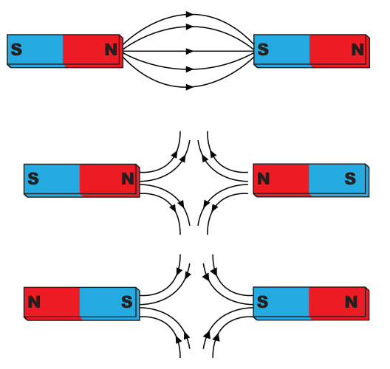
Attract or repel?
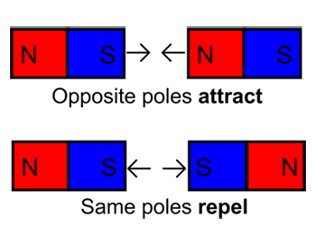
Have you ever held two magnets close to each other? They do not act like most objects. Have you noticed that, if you try to push the South poles together, they repel each other? If you try to push the North poles together, they also repel each other. However, if you push the North and South poles together they attract and pull together – with magnets, opposites attract.

EXPLORE AND INVESTIGATE:
HYPOTHESISE  ENQUIRE  TEST  RECORD  REPORT  CONCLUDE | Testing magnetic strength and magnetic fields:  Test 1:  - Testing a variety of magnets, add one paper clip at a time to test how many steel paperclips the magnet can hold.  - Record the results of the different magnets.  - What did you discover? What does this tell you about each magnet and its magnetic field?  Test 2:  - Place a ruler flat on a table and a magnet at the 0 measure of the ruler.  - Place a steel paperclip at the 30cm measure of the ruler. Does it attract to the magnet?  - Move the paperclip, 1cm at a time, closer to the magnet and record whether it is attracted or not.  - Repeat and record for different magnets.  - What did you discover? What does this tell you about each magnet and its magnetic field?
Testing materials – magnetic or not?
- Compile a collection of everyday objects.
- Using a magnet, test whether these materials are magnetic or not.
- Record your results.
- What did you discover? What does this tell you about the properties of the material? What must it contain?
KEY ASSESSMENT AND APPLICATION OPPORTUNITIES:
EXS:  What is a magnetic force?  What does magnetic mean?  How do we know if materials are magnetic?  Describe what happens when you put different parts of 2 magnets together.  Why are only some metals magnetic?  Can you find objects around the classroom that are magnetic? What material is it? |  |  |  |  |  | GDS:  Can you see a magnetic field? How do you know it exists?  Explore the use of magnets and explain how they can be useful in everyday life.  Use a labelled diagram to explain to others what you understand about magnetic fields.  Use a labelled diagram to explain to others what you understand about magnetic poles.

YEAR 5: SPRING 1 – INVENTIONS
SCIENCE: Forces
UNDERSTAND, DESCRIBE AND EXPLAIN: Gravity
To understand and explain that unsupported objects fall towards the Earth because of the force of gravity acting between the Earth and the falling object  Learning links:  Year 3: Science  Forces and magnets  Year 5: DT  Building and testing air pressure rockets and exploring the forces in action  Year 4: History  Stuart Britain | Forces | Push | Pull |  | Twist | Sir Isaac Newton | Theory of Gravity, 1687
 | Interaction | Movement | Speed |  | Direction | Shape | Affect (v)/Effect (n)
 | Gravity | Earth | Planets |  | Sun | Exerted | Gravitational force
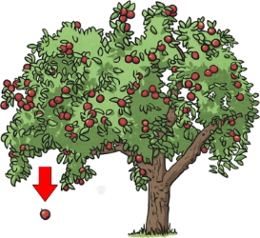
You should remember learning about forces and magnets in Year 3. If you cannot remember, or need to refresh your understanding, have a read of the Year 3 Forces and Magnets Learning Journey Map.

What are forces?
A force is a push, pull or twist acting on an object because of the object's interaction with another object.
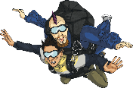
Forces affect the movement or shape of an object. They can make an object start to move, stop moving, move faster or move more slowly. They could also make an object change its shape or cause a moving object to change direction.
gravity

Gravity:
Gravity is an invisible force that pulls the Earth and other planets towards the Sun. It also keeps us and other objects on the ground. We can represent gravity with an arrow pointing down towards the Earth.
Gravity is a pulling force exerted by the Earth. The gravitational force from the Earth pulls in a direction towards the centre of the Earth. Gravity is pulling the apple and these skydivers towards the Earth.
Anything, which has mass, exerts a gravitational force. The larger the mass, the greater the gravitational force.
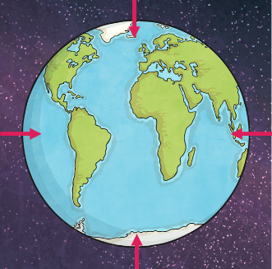
For example, the Sun has a mass so huge that it creates a gravitational force strong enough to hold the entire solar system in place. Planet Earth has a mass big enough to exert a gravitational force strong enough to keep everything on it in place and to keep a natural satellite (the moon) in orbit.
The Moon’s gravity is one-sixth (1/6) of Earth’s gravity, so an object with the same mass will weigh differently on Earth than it does on the Moon. For example, an astronaut weighs 120kg on Earth. Even though the astronaut does not change size or mass, their weight on the Moon would be just 20kg.

Weight and Mass:
Mass is a measure of how much matter or 'stuff' is in an object. Small objects may contain a lot of matter, like a metal ball. Larger objects may contain very little matter, like a polystyrene block.
Weight is the mass of an object, affected by how strong the gravity is. Therefore, weight is also a force. Weight is the force of a mass pushing down (by gravity) on the surface on which it is standing. Weight is measured in Newtons.
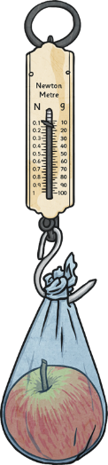
Sir Isaac Newton:
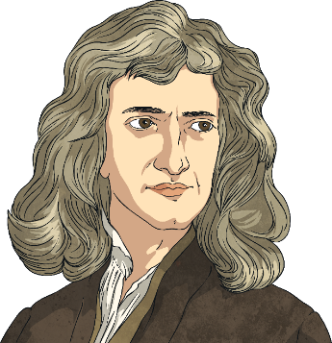
Sir Isaac Newton was born in 1642 and is known as one of the greatest scientists to have lived, as he was the man who published his theory of gravity in 1687. Legend has it, that Newton was hit on the head with an apple and that is how he discovered gravity. However, this is not quite true… He did see an apple fall from a tree, but rather than hitting him on the head, it got him thinking and that is how he worked out that gravity must exist.
Newton discovered that Earth must have a force, which pulls things down instead of letting things float upwards. We call this force gravity. Newton discovered that gravity attracts all objects towards each other. The bigger an object, the more gravity it would have. He developed this theory to work out that gravity kept the moon in orbit around Earth.
Did you know?
This is why the weight of 1 Newton is approximately the same as one apple.
EXPLORE AND INVESTIGATE:
HYPOTHESISE  ENQUIRE  TEST  RECORD  REPORT  CONCLUDE | Measuring weight on different planets, moons and stars:  Scales have been designed to incorporate the Earth’s gravity (9.8 m/s) when measuring mass so that the items weight is reflective of that on Earth.  However, depending on the size of the planet/star, the force of gravity is different.  Use a set of measuring scales to measure the weight of various everyday objects on Earth.  You can work out how much the same item would weigh if placed on different stars, moons or planets by multiplying or dividing their Earth weight.  - Gravity of the Sun = 27 x stronger than the Earth.  - Gravity of the Moon = 6 x weaker (divide) than the Earth.  - Gravity of Jupiter = 2.5 x stronger than the Earth.  - Gravity of Mars = 3 x weaker (divide) than the Earth.
KEY ASSESSMENT AND APPLICATION OPPORTUNITIES:
EXS:  Name the force that pulls objects towards the Earth.  Who discovered gravity? When was the theory published?  What is gravity? Can you explain it simply in 5 sentences?  What is the difference between weight and mass?  How does gravity differ on different planets? What would happen if I dropped the same tennis ball on Earth, the Moon and Jupiter? |  |  |  | GDS:  What would happen if there was no gravity on earth?  Why do we need gravity?  Could humans survive without gravity?  Using labelled diagrams, create an encyclopaedia page to explain gravity to a target audience of your choice – consider your language choices.
UNDERSTAND, DESCRIBE AND EXPLAIN: Air resistance, water resistance and friction
To identify and understand the effects of air resistance, water resistance and friction, that act between moving surfaces  Learning links:  Year 3: Science  Forces and magnets  Year 5: DT  Building and testing air pressure rockets and exploring the forces in action  Year 4: History  Stuart Britain | Air resistance | Gas | Counteracts |  | Galileo Galilei (1564 – 1642) | Opposing forces | Surface area | Comparison
 | Water resistance | LIquid | Dense |  | Streamline(d) | Efficient | Reducing resistance
What is air resistance?
Air resistance is the name of the force that is pushing up against the parachute.
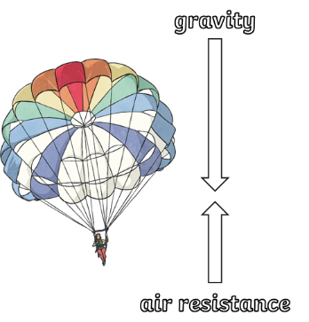
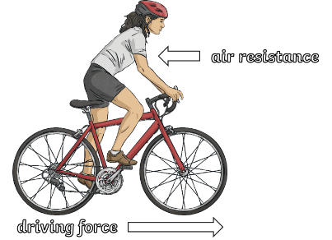
Gravity is pulling the skydivers towards the ground. However, they are slowed down because a force (air resistance) pushes against the inside of the parachute and they descend more slowly. Gravity and air resistance are opposing forces in this situation but gravity is still the stronger of the two.
Air resistance can be a useful force, but it can also be unhelpful in certain situations.
In a cyclist’s situation, the air resistance is unhelpful as it is slowing down the speed being generated by pedalling; making it harder work to move forward.
When parachuting, air resistance is a useful force as it counteracts the force of gravity to slow the speed down so that the passenger can land safely.

Galileo Galilei, (1564-1642)
Galileo Galilei was an Italian scientist and mathematician who wondered about air resistance.
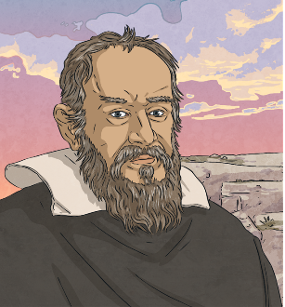
In 1590, he decided to carry out an investigation to find the answer.
He climbed to the top of the Leaning Tower of Pisa with two balls of similar shape and size, but with different masses. He dropped both of the balls from the top of the tower at the same time. Both balls hit the ground at the same time.
Galileo's experiment proved that all objects fall at the same rate, no matter what their mass is. But this can seem hard to believe! Think about a feather and a hammer. If you dropped both objects at the same time, would they hit the ground at the same time? No, they wouldn’t. However, that isn’t because of their mass, it is because of their ability to ‘catch air’.

What do you think happened when astronauts stood on the Moon and dropped these two items at the same time?
The feather and the hammer hit the surface of the Moon at the same time! This proved that Galileo’s findings are correct.
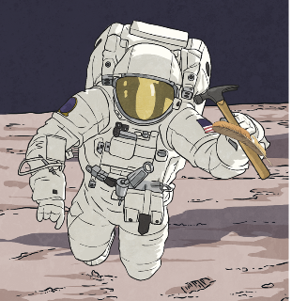
Why did this happen?
There is no air on the Moon. Air pushes against any object moving through it: air resistance.
On Earth, air resistance acts on both the hammer and the feather. The feather has a large surface area in comparison to its mass. The hammer has a small surface area in comparison to its mass. Therefore, air resistance has a greater upwards force on the feather causing the hammer to reach the ground first. Since there is no air on the Moon, there is no air resistance to push against the feather, so the two objects fall at the same speed.

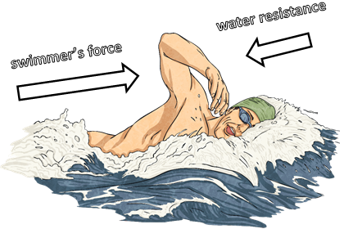
What is water resistance?
In the same way that air can cause resistance to moving objects, so can water. Being a liquid (more dense than air), the effects of water resistance are more obvious.
If you have ever walked through water, you will have felt the effects of water resistance pushing against you.
However, water resistance is a useful force as it helps you to swim. When you push against the water with your hands, the water resistance pushes back and helps you to move forward, like using oars to push against the water to row a boat.
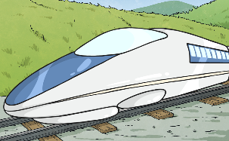
Streamline shapes to reduce resistance:
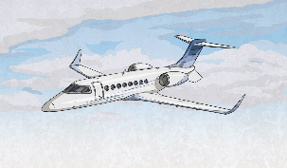
For speed and direction purposes, air and water resistance are unhelpful forces as they counteract the force creating forward motion. It is possible to reduce the effects of water and air resistance. For example, cars, trains, planes and boats are designed to reduce the effects of air and water resistance to ensure the most efficient use of energy and fuel. Objects that do not experience much water or air resistance are described as streamlined.
This high-speed train and jet aircraft have been designed to be streamlined and reduce the impact of air resistance.
Both examples have a pointed (cone-shaped) nose so that they can ‘cut’ through the air, a low, curved top to allow the air to flow over and around it easily and they are both also made of smooth, shiny materials.

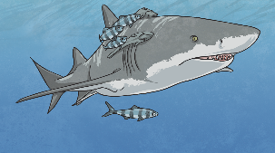
Looking at nature too, we can see how certain animals have adapted to be more streamlined.
The great white shark, for example, has a pointed nose to cut through the water, and a smooth, low, curved back to allow the water to flow over and around it. It does not create much water resistance so it can move through the water quickly.
EXPLORE AND INVESTIGATE:
HYPOTHESISE  ENQUIRE  TEST  RECORD  REPORT  CONCLUDE | Investigating air resistance:  - Find a safe space to drop paper from a height.  - Each group has 5 pieces of paper: 1 piece will remain in its original form, another piece will be scrunched in to a ball. The remaining 3 pieces can be designed in to any chosen shapes/forms by folding only. The paper must not be cut or ripped, only folded. Nothing can be stuck to or added to any sheet of paper.  - One piece of paper can then be dropped from a height at once. Using a stopwatch, time how long each piece takes to reach the ground.  - Record the results. What did you discover? What does this tell you about air resistance, shape design and surface areas?
Investigating water resistance:
- Fill a deep container or wide measuring cylinder with water.
- Using 3 equal portions of modelling clay, create 3 shapes (e.g. cone, sphere, cube).
- One at a time, drop each shape in to the water-filled container.
- Using a stopwatch, time how long each shape takes to reach the bottom of the container and record the results.
- What did you discover? What does this tell you about water resistance, shape design and surface areas?
KEY ASSESSMENT AND APPLICATION OPPORTUNITIES:
EXS:  Using diagrams, can you explain air and water resistance as forces.  Describe how air resistance/water resistance can be a useful or unhelpful force in different situations.  What does ‘streamlined’ mean?  Describe how air and water resistance could be reduced or increased and for what this could be useful. |  |  |  | GDS:  If you were stood on the moon and dropped 2 items, which would reach the ground first? Why is this?  Would a parachute be of use if landing on the moon? Why?  Looking at a creature designed to be streamlined, label and justify how it has adapted to be less resistant to air or water.

UNDERSTAND, DESCRIBE AND EXPLAIN: Levers, pulleys, cogs and gears
To recognise that some mechanisms, including levers, pulleys and gears, allow a smaller force to have a greater effect  Learning links:  Year 3: Science  Forces and magnets  Year 3: DT  Building and testing magnetic cranes with a pulley system | Machines | Devices | Gears | Cogs | Wheels | Ramps |  | Wedges | Levers | Screws | Pulleys
 | Fulcrum/Pivot |  | Direction |  | Speed | Force |  | Increase | Decrease | Drive gear | Clockwise/Anticlockwise
Machines:
Machines are devices that change the direction or size of a force. There are six types of simple machines: wheels, ramps, wedges, levers, screws and pulleys. Most simple machines reduce the force you need to apply to lift or move a heavy object by making the distance over which you apply the force larger than the distance the object moves.

Levers:
A lever is one of the oldest and simplest machines used by humans. A lever consists of just 2 parts: a beam (the long part) and a fulcrum or pivot (hinge). The beam rotates along the fulcrum like in this diagram here.
Levers are particularly useful because they allow humans to lift heavy objects by applying less force than if trying to lift without the lever. The boy in the picture is lifting a heavy log. It is so heavy he can hardly lift it. His friend is lifting a similar heavy log. He is lifting it more easily because he is using a small log resting on another log as a lever. The lever makes lifting the heavy log easy. A lever always rests on a pivot. In this case, the log on the ground is acting as a pivot. A lever always has three things – the point where you push or pull, the point where it pivots, and the point where the force is applied.
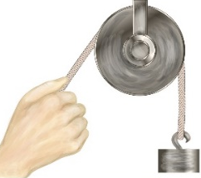
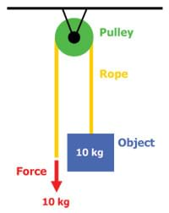
Pulleys:
A pulley is a wheel with a grooved rim around which a cord passes. The pulley acts to change the direction of a force applied to the cord and is used to raise heavy weights.
In the picture, the boy and the girl are both lifting a bucket full of wood. The girl finds it difficult, but the boy is using a pulley tied to a tree and is lifting the bucket with the rope passing under the pulley. He has to exert the same pull as his friend, but he finds it easier to pull on the rope than she does to lift the bucket up by the handle.

Cogs and Gears:
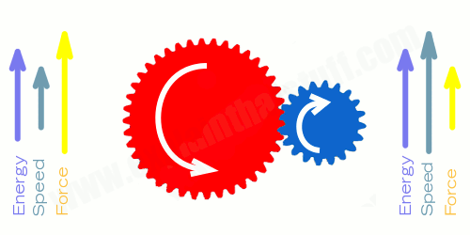
Gears are wheels that have teeth, or cogs, around the edges. The cogs of one gear fit into the cogs of another. They move in opposite directions. In other words, when one gear turns to the right (clockwise), the gear attached to it will turn to the left (anticlockwise). This pattern continues to repeat, regardless of how many gears are attached to each other. As gears turn, energy is transferred from one gear to another. They can either increase or decrease speed or force.
If a large gear is attached to a small gear with the large gear as the drive gear (first turn), this will cause the small gear to turn. As the larger gear (drive gear) turns, the small gear will speed up to keep up with it. This type of gear sequence increases speed.
Gears are very useful for transferring energy in to larger movements, speed or power.
They are used widely in bikes, motorbikes and cars.
EXPLORE AND INVESTIGATE:
HYPOTHESISE  ENQUIRE  TEST  RECORD  REPORT  CONCLUDE | Investigating levers and fulcrums:  - Place a weight/single object on one end of a 30cm ruler on the 0cm mark.  - Place a pencil (fulcrum) underneath the ruler at the opposite end on the 30cm mark.  - Place an equal weight/single object on the ruler at the 30cm mark. Did this lift the weight on the opposite side? Why not?  - Move the pencil (fulcrum), one cm at a time, towards the original weight. Record whether the weight is lifted by the lever.  - At what distance, on either side of the fulcrum, does the lever work?  - Experiment with a lighter weight at the opposite end of the lever. What is the lightest weight that can be used to lever the weight?  - What did you discover? What does this tell you about the positioning of a fulcrum and the usefulness of a lever in everyday life?
Investigating pulleys:
- Set up a simple pulley mechanism by taping a metal can to a gap between 2 tables and laying a piece of string over the top.
- Attach a selected weight to one end of the string and allow it to rest on the ground beneath the table.
- Investigate and explore how the pulley system makes it easier to lift the weight. If available, use a force metre to measure the force needed to lift the weight with one pulley.
- One at a time, add more pulleys to the system. Is it easier to lift the weight? Has the amount of force needed reduced?
- What did you discover? What does this tell you about increasing the number of pulleys and the usefulness of a pulley in everyday life?
Investigating gears:
- Using a compass, draw and cut various sized circles out of cardboard.
- Cut lollipop sticks and stick to the cardboard to create cogs on their gears.
- Once they have created each gear, they can be attached to a larger piece of cardboard using a cocktail stick/skewer.
- From this gear, begin to create a different size gear with varying numbers of teeth to place next on the cardboard.
- Once completed, one gear can be selected as the drive gear and the children can explore how the force from the drive gear changes as it moves through the different gears. Experiment by changing the drive gear.
- What did you discover? What does this tell you about how gears can increase or decrease the original force or speed?
KEY ASSESSMENT AND APPLICATION OPPORTUNITIES:
EXS:  What effect can mechanisms like pulleys, levers and gears have?  Using diagrams, explain how a lever/pulley/gear works.  If a large gear is used as the drive gear and is connected to a smaller gear, how will this affect the original force? |  |  |  |  |  |  | GDS:  Can you investigate at what distance the fulcrum in a lever system must be to lift a weight with half of its weight?  What happens to the force needed when you add a pulley to a single pulley system?  If a small gear is used as the drive gear and is connected to a larger gear, how will this affect the original force?

