Year 6 Overview: Spring 1 term 2020
English | Values | Physical Education
A Monster Calls – Patrick Ness  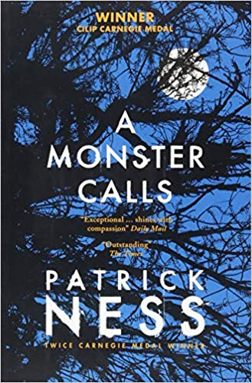  Conor has the same dream every night, ever since his mother first fell ill, ever since she started the treatments that don't quite seem to be working. But tonight is different. Tonight, when he wakes, there's a visitor at his window. It’s ancient, elemental, a force of nature. And it wants the most dangerous thing of all from Conor. It wants the truth. Patrick Ness takes the final idea of the late, award-winning writer Siobhan Dowd and weaves an extraordinary and heart-breaking tale of mischief, healing and above all, the courage it takes to survive.  In English, we will be writing to entertain. Children will be taught the skills required to write across different genres and hone their skills by producing a range of original writing.  We will also be studying poetry throughout Spring 1. Year 6 pupils will be reading and analysing Rudyard Kipling’s ‘If’ and Shakespeare’s ‘Sonnet 18’ amongst others. | The Aspirations condition for this term is:  Curiosity and Creativity  …characterised by inquisitiveness, eagerness, a strong desire to learn new or interesting things and a longing to satisfy the mind with new discoveries.  Our learning skill focus this half term is independence. Children will be given the skills to take greater ownership and responsibility of their learning. | With Mr White and our class teachers, we will continue to develop our fundamental movement skills through net and wall games:  *UNDERARM THROW, CATCHING, STRIKING WITH A RACQUET (FOREHAND AND BACKHAND)  Having developed our balance and core strength, we will be continuing with GYMNASTICS focusing on:  *FLOOR SHAPES, FLOOR MOVEMENT, BENCH BALANCE, VAULT, CLIMBING AND TRAVERSING APPARATUS*
 | Maths | Science
 | 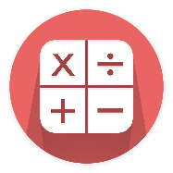  In maths this term, in addition to regularly revising our arithmetic, we will be focusing on: fractions, percentages, algebra, measurement and ratio.  Within these areas, children will be problem-solving and reasoning to deepen their mathematical understanding and apply their knowledge in real-life situations. | Our driving question this half-term is ‘how can we, as inventors, create a monster warning system?’  The children will be learning about light and electricity. They will be investigating how to recognise that light travels in straight lines. They will then use this knowledge to explain how objects are seen. Pupils will also investigate shadows and learn how this links to the way that light travels.  Year 6 will also learn how to construct a simple series circuit. They will identify various parts of a series circuit and learn how to identify whether a lamp will light by looking at a basic circuit diagram.  On the first day back, the children’s curiosity and creativity will be satisfied as it’s our Science Day! Pupils will enjoy six exciting science activities with 6 different teachers.
Design Technology | Growth Mindset
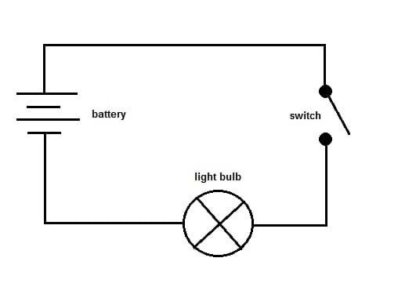  Linking to our Aspirations Condition, their science topic and ‘A Monster Calls’, pupils will design, create and evaluate a monster alarm system. | Growth Mindset underpins everything we do at Ocean. The children will have plenty of opportunities to strengthen their growth mindset and become more resilient learners by remembering the power of ‘yet’. Despite the learning challenges ahead of them, Year 6 pupils are equipped with the power to persevere. This term, as with any other, pupils will be exposed to challenge and a growth mindset is key to tackling challenging learning. All successful people fail regularly.
Dates for your diary | Music | PSHE
6/1/2020 – INSeT Day – School closed  7/1/2020 – Spring 1 starts - Science day  14/2/2020 – Last day of Spring 1 | 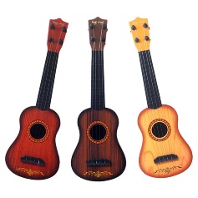  This half-term, the pupils will be learning ukulele with Mr Beedie. They will learn some basic chord shapes and practice performing. The ukulele is a fantastic, affordable instrument that is enjoyable to play and can pave the way for learning other stringed instruments. | In PSHE, we will be thinking about how to stay motivated and resilient when something is challenging and maintaining a growth mind-set when working towards our hopes and dreams .

