Year 4 Overview: Spring Term 1
English | VALUES |  | Physical Education
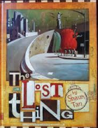  WRITING: TO ENTERTAIN  Class reader: ‘The Lost Thing’ by Shaun Tan  We will be moving on to fiction writing, using the picture book ‘The Lost Thing’ to write our own adventure stories about a lost creature. We will be focusing on punctuating direct speech accurately along with a continued focus on sentence structure.  READING:  THROUGH OUR READING SEESIONS WE WILL FOCUS ON:  - Understanding the purpose, audience and  formality of a text.  - Looking at language choices.  - Answering questions based on the text.  - Making informed decisions based on evidence from the text.  SPELLING  Each week we will learn to spell 2/3 words of the National Curriculum year 4 spelling list. Look out for these in your child’s homework diary each week | The Aspiration condition this term is:  Curiosity and creativity  Our Learning skill focus is: INDEPENDENCE  We will be looking at what independence means, encouraging the children to gain confidence and the ability to learn from mistakes as they build successful and productive lives. |  | In PE and games this term, we will be working with Mr White to continue to develop our fundamental movement skills across a variety of games and sports, with a focus on invasion and bat and ball games.  Our other PE sessions will have a dance and gymnastics focus, along with continuing to work on our ‘Personal Challenges’ – the children working to improve their personal bests in long jump, howler throw and long and short distance running.
 | Driving Question |  | Growth Mindset
 | How can we, as the producers of a rock band, create the greatest rock show that Poole has ever seen? |  | 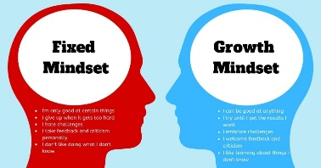  The children will continue to face challenging activities, whereby they will continue to develop their growth mindset, understanding that they can’t do it ‘yet’.
Computing | Maths |  | Science
This half term, we have been given an incredible mission by a local rock band – can we design the lighting for their next gig? We will be creating stage dioramas with lighting provided by micro bit computers to share our designs with the band.  They will develop their computing skills by:  - designing, writing and debugging programs that accomplish specific goals  - use sequence, selection, and repetition in programs  - use logical reasoning to explain how simple codes work and to detect and correct errors in their coding. | In maths, we will focus on place value, addition and subtraction throughout the term, which includes:  - Length and perimeter  - Area  - Multiplication and division 4 digit numbers using a written method  Through daily arithmetic sessions, we will be focusing on:  - Using written methods for the 4 calculations (+ - x ÷)  - Fractions (adding and subtracting, fractions of a number)  - Working with decimal numbers.  We will also be learning our times tables in daily sessions, and appreciate your support in helping to learn these at home too. |  | This half term, we will be focusing on electricity  In this topic, we will:  - Identify appliances which run on electricity  - Construct simple circuits and identify the key parts  - Test whether or not a bulb will light on a complete/incomplete loop  - Recognise that a switch opens and closes a circuit  Through experiments and investigations, we will:  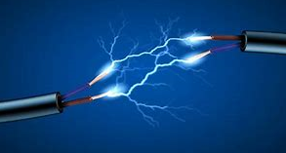  - Pose questions and make predictions  - Record and present results  - Draw conclusions
SMSC & British Values | PSHE |  | Creative
Spiritual: Experiencing and respecting other beliefs.  Moral: Knowing the difference between right and wrong.  Social: Developing leadership, cooperation and teamwork.  Cultural: Appreciating other cultures and what they offer.  Democracy: Developing understanding of different opinions and our right to vote.  One World: Developing harmony between different cultural traditions. | Jigsaw: Dreams and Goals  - Talk about a person who has faced difficult challenges and achieved success.  - Identify a dream/ambition that is important to me.  - Working out the best ways to achieve a goal  - Recognise obstacles which might hinder achievements and identify steps to overcome them.  - Evaluate and identify how I can be better next time. |  | This half term will see the children learning:  ART- Pupils will be creating portraits of famous musicians.  MUSIC- The pupils have an exciting opportunity to learn to play the steel drums with Mr Beedie.  DT – With Miss Jordan, we will be exploring wearable technology and we will be cooking energy bars/rock cakes with Mrs Turner and Mr Broadbent.
Dates for your diary:  06.01.20: Inset Day  07.01.20: Science Day  10.01.20: Swimming Group 2 session 1  16.01.20: Rock band performance 6:15-7:00 (letter to follow)  17.01.20: Swimming Group 2 session 2 |  | Dates for your diary:  24.01.20: Swimming Group 2 session 3  31.01.20: Swimming Group 2 session 4  07.02.20: Swimming Group 2 session 5  14.02.20: Finish for half term

